LEPC PUBLIC REQUESTS FOR INFORMATION
The Superfund Amendments and Reauthorization Act (SARA) of 1986 and the Freedom of Information Act mandates that the public shall be provided access to facility specific chemical inventories, hazardous material release reports, safety data sheets (SDS) and local emergency response plans in the possession of the Seward/York LEPC.
The Seward/York County Local Emergency Planning Committee (LEPC) has established the following procedure governing the release of records to the public and governmental agencies. This procedure is in compliance with state and federal guidelines, and the bylaws of the LEPC
POLICY
Requests for information will be handled in accordance with the Seward County Open Records Request Policy.
1. Requests will be directed to the Seward/York Emergency Management Office to research and answer the request.
The Seward County Attorney will advise the Emergency Management Director and the request will be answered using the guidelines of the SARA Title III regulations. This allows for the response to be answered within 45 calendar days.
2. All requests for information under EPCRA for public documents provided to or generated by the LEPC must be in writing and indicate the site of concern (Multiple sites not permitted).
3. The formal response to the requestor may indicate that there are documents available for review; and the time, date, and location of the review (as mutually arranged) given.
4. The records requested will be made available for viewing only.
5. Copies of the written response will be kept on file at the Emergency Management Office.

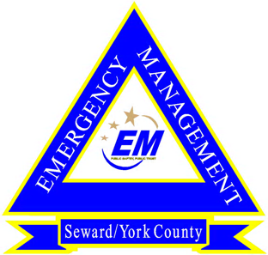
SEWARD/YORK COUNTY EMERGENCY MANAGEMENT
322 SOUTH 14TH, SUITE 1 510 Lincoln Ave.
SEWARD, NE 68434 York, NE 68467
PH. 402-643-4722 PH. 402-362-7744

OPEN RECORDS REQUEST

Requestor Information

Request Date: ___________________ Phone Number: ____________________
Name: ____________________________________________________________________
Company: __________________________________________________________________
Street Address: ______________________________________________________________
City: _________________________ State: ______________ Zip: ___________
Email: _____________________________________ Fax Number: ________________

Information Requested

Name of Facility:________________________________________
Address of Facility: ______________________________________
City: ______________________ State: ____________ Zip Code: ________________

Standard Information Requests (Separate Form Required for Each Facility)
Please check appropriate box (es)

- -Hazardous material release reports on record with the LEPC.
- -Tier Two chemical inventory information.
- -Safety Data Sheets for a specific chemical (s).
- -Current Chemical Emergency Response and Preparedness Base Plan.

*DISCLAIMER: The data in a Safety Data Sheet is offered for your consideration, investigation and verification. The data is presented in good faith and was obtained from sources Seward/York LEPC believes to be reliable. However, Seward/York LEPC makes no representation as to the completeness or accuracy of this information. Thus, we expressly disclaim responsibility or liability arising out of reliance of this information. Please contact the manufacture of the chemical for specific safety information.

Signature: ________________________________________Date: ___________________________

The Seward/York Local Emergency Planning Committee will make a good faith effort to provide the requested information within 45 days.

